Life Cycle Plan (LCP)

Yanomamo Interactive DVD/Online

Team No. 6

Reetika Rastogi - Project Manager, Life Cycle Planner
Rohit Mani - Requirements Engineer, Life Cycle Planner
Sanjay Kutty - Feasibility Analyst, Software Architect
Shruti Sannabhadti - Software Architect, Prototyper
Tushar Saxena - Operational Concept Engineer, Requirements Engineer
Cristina Cano - Prototyper, Feasibility Analyst

12/02/2013

Version History
Date | Author | Version | Changes made | Rationale
09/27/13 | RR, RM | 1.0 | Updated Section 1.1 – 3.3 | Initial draft of the Life Cycle Plan; To be included in the VC Package.
10/12/13 | RR,RM | 2.0 | Updated Section 4.1 – 5 | Fixed Defects. To be included in the Draft FC Package.
10/14/13 | RM | 2.1 | Updated Section 2, 5 | Fixed Defects.
10/16/13 | RM | 2.2 | Updated Resource Estimation | Incorporated ARB Feedback
10/23/13 | RM | 3.0 | Updated section 6.1 | To be included in the DC Package
11/30/13 | RM | 4.0 | Updated section 2, 6 | Final Draft of the LCP to be included in the TRR Package

Table of Contents
Life Cycle Plan (LCP) i
Version History ii
Table of Contents iii
Table of Tables iv
Table of Figures v
1. Introduction 1
1.1 Purpose of the LCP 1
1.2 Status of the LCP 1
1.3 Assumptions 1
2. Milestones and Products 2
2.1 Overall Strategy 2
2.2 Project Deliverables 3
3. Responsibilities 6
3.1 Project-specific stakeholder’s responsibilities 6
3.2 Responsibilities by Phase 6
3.3 Skills 7
4. Approach 8
4.1 Monitoring and Control 8
4.2 Methods, Tools and Facilities 9
5. Resources 10
6. Iteration Plan 15
6.1 Plan 15
6.1.1 Capabilities to be implemented 15
6.1.2 Capabilities to be tested 16
6.1.4 CCD Preparation Plans 17
6.2 Iteration Assessment 17
6.2.1 Capabilities Implemented, Tested, and Results 17
6.2.2 Core Capabilities Drive-Through Results 17
6.3 Adherence to Plan 18

Table of Tables
Table 1: Artifacts Deliverable in Exploration Phase 3
Table 2: Artifacts deliverable in Valuation Phase 4
Table 3: Artifacts deliverable in Foundations Phase 4
Table 4: Artifacts deliverable in Development (Construction) Phase 5
Table 5: Artifacts deliverable in Development (Transition) Phase 5
Table 6: Stakeholder's Responsibilities in each phase 6
Table 7: Skills 7
Table 8: Methods, Tools and Facilities 9
Table 9: Module lists and SLOC of each module 10
Table 10: COCOMOII Scale Drivers 11
Table 11: COCOMOII Cost Drivers for Video Rendering Module 12
Table 12: COCOMOII Cost Drivers for Linking Tool 13
Table 13: Construction iteration capabilities to be implemented 15
Table 14: Construction iteration capabilities to be tested 16
Table 16: Capabilities implemented, tested, and results 17

Table of Figures
Figure 1: COCOMOII Estimation Results 11
Figure 2: COPSEMO Tab 11
Figure 3: COCOMOII Scale Factors 12
Figure 4: COCOMOII Cost Drivers #1 13
Figure 5: COCOMOII Cost Drivers #2 14

    - Introduction

Purpose of the LCP
The purpose of the LCP is to provide a starting point for defining the steps and associated activities that make up the software development process.

Status of the LCP
The status of the LCP is currently at the Development Commitment Package version number 3.0. This is the version of the LCP to be included in the DC Package.

Assumptions
  - The duration of the project is 12 weeks (Fall 2013)
  - There are six on-campus members in the project team
  - NDI-Intensive Process Model is being used for this project
Instructional Incremental Commitment Spiral Model – Software Electronic Process Guide is being used as the guideline for our project.
    - Milestones and Products

Overall Strategy
Yanomamo Interactive DVD/Online is following NDI-Intensive process because there are many existing Non-Development Items which can be used to deliver the core capabilities of the system.

Exploration phase
Duration: 09/09/2013 – 9/27/2013
Concept: The team explores the current system, the system and software requirements, and life-cycle plan. In this phase, the team will prioritize the capabilities, conduct investment and feasibility analysis, and implement the software prototype.
Deliverables: Valuation Commitment Package, Client Interaction Report, Project Reports and Plans, Weekly Effort Report.
Milestone: Valuation Commitment Review
Strategy: One Incremental Commitment Cycle

Valuation phase
Duration: 09/28/2013 – 10/14/2013
Concept: In this phase, the team develops the operational concept, provide feasibility evidence, improve the initial prototype and define the quality policy.
Deliverables: Draft Foundations Commitment Package, Core Foundations Commitment Package, Initial Prototype, Project Reports and Plans, Weekly Effort Report.
Milestone: Foundations Commitment Review
Strategy: One Incremental Commitment Cycle

Foundations phase
Duration: 10/17/2013 – 10/23/2013
Concept: Continue risk assessment process, regular stakeholder meetings are to be taken every week, regular progress reports and effort reports to be submitted every Monday and every other Monday respectively, project plans are to be prepared and released on project web-page, risk resolution, assessing project status, sharing implementation jobs. Start work on linking tool and start making test plans and schedules.
Deliverables: Development Commitment Package, Initial Prototype, Project Reports and Plans, Weekly Effort Report.
Milestone: Development Commitment Review
Strategy: One Incremental Commitment Cycle

Development phase - Construction
Duration: 10/24/2013 – 11/15/2013
Concept: Work on synchronization of all documents. Prepare for the core capability drivethrough by starting work on all the modules required to deliver the core capabilities of the system. Continue risk assessment process; regular stakeholder meetings are to be taken every week, regular progress reports and effort reports to be submitted every Monday and every other Monday respectively; project plans are to be prepared and released on project web-page, risk resolution, assessing project status, sharing implementation jobs. Continue work on linking tool and start the testing process.
Deliverables: Enhanced Prototype of the system consisting of all core capabilities.
Milestone: Core Capability Drivethrough

Development phase - Transition
Duration: 11/16/2013 – 12/15/2013
Concept: Finishing the proposed system is the main focus of this phase. Finishing work on the linking tool also takes top priority. Testing must be performed by the development team as soon as a capability is delivered. Preparing a transition plan and training the users of the system to use the interface is also done in this phase. Continue risk assessment process; regular stakeholder meetings are to be taken every week, regular progress reports and effort reports to be submitted every Monday and every other Monday respectively; project plans are to be prepared and released on project web-page, risk resolution, assessing project status, sharing implementation jobs
Deliverables: Final Product, All Planning, Testing, Quality and Transition Documents.
Milestone: Transition Readiness Review

Project Deliverables

Exploration Phase
Table 1: Artifacts Deliverable in Exploration Phase
Artifact | Due date | Format | Medium
Client Interaction Report | 9/20/2013 | .doc, .pdf | Soft copy
Valuation Commitment Package  - Operational Concept Description (OCD) Early Section  - Life Cycle Plan (LCP) Early Section  - Feasibility Evidence Description (FED) Early Section | 09/27/2013 | .doc, .pdf | Soft copy
Project Effort Report | Every Monday | Text | ER system
Project Plan | Every other Monday | .mpp, .pdf | Soft copy
Progress Report | Every other Monday | .xls | Soft copy
Risk Analysis | Every other Monday | Text | Part of Progress Report

Valuation Phase
Table 2: Artifacts deliverable in Valuation Phase
Artifact | Due date | Format | Medium
Initial Prototype | 10/04/2013 | .html | Soft copy, Demo
Draft Foundations Commitment Package  - Operational Concept Description (OCD) All Sections  - Prototype (PRO) All Sections  - Life Cycle Plan (LCP) All Sections  - UML Model  - System Software Architecture Description (SSAD) Early Sections  - Feasibility Evidence Description (FED) All Sections | 10/16/2013 | .doc, .pdf | Soft copy
Project Effort Report | Every Monday | Text | ER system
Project Plan | Every other Monday | .mpp, .pdf | Soft copy
Progress Report | Every other Monday | .xls | Soft copy
Risk Analysis | Every other Monday | Text | Part of Progress Report

Foundations Phase
Table 3: Artifacts deliverable in Foundations Phase
Artifact | Due date | Format | Medium
Draft DC Package | 10/21/13 | .doc, .pdf | Soft Copy
Project Effort Report | Every Monday | Text | ER system
Project Plan | Every other Monday | .mpp, .pdf | Soft copy
Progress Report | Every other Monday | .xls | Soft copy
Risk Analysis | Every other Monday | Text | Part of Progress Report

Development Phase - Construction
Table 4: Artifacts deliverable in Development (Construction) Phase
Artifact | Due date | Format | Medium
Enhanced Prototype | 11/15/13 | .html | Soft Copy, Demo
Project Effort Report | Every Monday | Text | ER system
Project Plan | Every other Monday | .mpp, .pdf | Soft copy
Progress Report | Every other Monday | .xls | Soft copy
Risk Analysis | Every other Monday | Text | Part of Progress Report

Development Phase - Transition
Table 5: Artifacts deliverable in Development (Transition) Phase
Artifact | Due date | Format | Medium
Final Product | 12/15/13 | .html | Soft Copy, Demo
Valuation Commitment Package  - OCD, LCP, FED, SSAD, TPC, TP, UM, TM, TPR | 12/06/13 | .doc, .pdf | Soft copy
Project Effort Report | Every Monday | Text | ER system
Project Plan | Every other Monday | .mpp, .pdf | Soft copy
Progress Report | Every other Monday | .xls | Soft copy
Risk Analysis | Every other Monday | Text | Part of Progress Report

    - Responsibilities

Project-specific stakeholder’s responsibilities
The client is Dr. Gary Seaman, head of USC Department of Anthropology. The users of the system are students, professors and researchers. The webmaster will be appointed by the client. The developer is Team #06. Dr. Gary Seaman is project-specific stakeholder and his role is to supply existing project assets to developers.

Responsibilities by Phase
Table 6: Stakeholder's Responsibilities in each phase
Team Member / Role | Primary / Secondary Responsibility
Team Member / Role | Exploration | Valuation | Foundations/  Development- Construction Iteration | Development- Transition Iteration
Reetika Rastogi  Project Manager, Life Cycle Planner | Primary Responsibility  Plan the project  Identify Risks  Secondary Responsibility  Update Bugzilla | Primary Responsibility  Co-ordinate team meetings  Secondary Responsibility  Update Bugzilla | Primary Responsibility  Plan the project  Assess Risks  Secondary Responsibility  Update Bugzilla | Primary Responsibility  Assess Metrics  Co-ordinate Meetings  Secondary Responsibility  Update Bugzilla
Rohit Mani  Requirements Engineer, Life Cycle Planner | Primary Responsibility  Plan the lifecycle  Facilitate WinWin Negotiations  Secondary Responsibility  Update website | Primary Responsibility  Plan the lifecycle  Assess Quality Management Strategy  Secondary Responsibility  Update website | Primary Responsibility  Plan the lifecycle  Plan Test Cases  Secondary Responsibility  Manage Quality | Primary Responsibility  Plan Test Cases  Perform Testing  Secondary Responsibility  Manage Quality
Sanjay Kutty  Feasibility Analyst | Primary Responsibility  Identify Risks  Secondary Responsibility  Update website | Primary Responsibility  Evaluate Feasibility of NDI  Secondary Responsibility  Update website | Primary Responsibility  Mitigate Risks  Work on linking tool  Secondary Responsibility  Update website | Primary Responsibility  Perform activities required for training  Secondary Responsibility  Update website
Shruti Sannabhadti  System Architect, Prototyper | Primary Responsibility  Identify NDI  Secondary  Responsibility  Develop the initial prototype | Primary Responsibility  Assess NDI  Secondary  Responsibility  Improve the prototype | Primary Responsibility  Develop Architecture  Secondary  Responsibility  Develop the linking tool | Primary Responsibility  Develop Architecture  Secondary  Responsibility  Develop User Manual
Tushar Saxena  Operational Concept Engineer | Primary Responsibility  Conceptualize the system  Secondary  Responsibility  Interact with clients | Primary Responsibility  Analyze current system  Secondary  Responsibility  Develop Operational Concept | Primary Responsibility  Add features to prototype  Secondary  Responsibility  Interact with the client | Primary Responsibility  Perform activities required for transition  Secondary  Responsibility  Interact with the client
Cristina Cano  Prototyper | Primary Responsibility  Develop the initial prototype  Secondary  Responsibility  Identify NDI | Primary Responsibility  Build the prototype  Secondary  Responsibility  Analyze Feasibility of NDI | Primary Responsibility  Add features to the base system  Develop the linking tool  Secondary  Responsibility  Interact with the client | Primary Responsibility  Finalize the product  Develop the linking tool  Secondary  Responsibility  Interact with the client

Skills
This is a one semester team. Therefore, none of the team members are continuing in 577b. In addition, all team members will be available till the end of 577a. No new team members will be needed. The current skills of the team members are listed for reference.
Table 7: Skills
Team members | Role | Skills
Reetika Rastogi | Project Manager, Life Cycle Planner | Project Management, MS Project, Bugzilla
Rohit Mani | Requirements Engineer, Life Cycle Planner, IV&V | Visual Paradigm, COINOMO, Winbook
Sanjay Kutty | Feasibility Analyst, System Architect | Java, Visual Paradigm
Shruti Sannabhadti | System Architect, Prototyper | Visual Paradigm, JavaScript, HTML5
Tushar Saxena | Operational Concept Engineer, Requirements Engineer | Visual Paradigm, Winbook
Cristina Cano | Prototyper, Feasibility Analyst | JavaScript, PHP, HTML5/CSS3, SQL, Bugzilla
    - Approach

Monitoring and Control
The following will be the various tools and documentation used by Team 06 to assist in the monitoring and control of the project. The key items are listed below and described in the following sections.

- Progress Reports – Bi-weekly report that keeps track of risks and COTS used
- Effort Reports - Documents each team member’s weekly effort
- Project Plan – Keeps track of deadlines, stakeholders and work involved in each section of the project
- Bugzilla – Defect Tracking and keeps track of the artifacts each team member is working on
- Client Meetings – Weekly meetings which demonstrate the project to the client and identify key drawbacks.

Closed Loop Feedback Control
The IIV&V team member processes all the documents before submission to the document database. The documents are shared on Google Drive so that it provides a centralized data store for any team member to access and review any document.

Reviews
- IIV&V reviews
- Commitment Package Evaluations
- Stakeholder commitment review
- Weekly stakeholder meetings
- Bugzilla
- Unplanned individual reviews

Methods, Tools and Facilities

Table 8: Methods, Tools and Facilities
Tools | Usage | Provider
Notepad++ | It is a lightweight and robust text editor used mainly for coding web languages | Open Source
MS Project 2013 | Assesses and mitigates risks in the system development life cycle | USC License
Balsamiq | Provides examples for user interface and system functionality, is helpful in the development of prototype | Demo Version
Microsoft Word | Used for documenting deliverables, LCP, OCD, FED | Team Members
Visual Paradigm | UML CASE Tool Used for modeling UML 2 diagrams | USC License
MS Excel | Used for documenting deliverables and results | Team Members

Resources
The following conditions are used to estimate the effort in Yanomamo Interactive System.
- This project has no budget for our development efforts. However, the client will provide the tools equipment and personnel to conduct testing.
- There are 6 developers.
- Estimated CSCI577a Effort : 6 team members at 6 hrs/week for 12 weeks
- Budget information: $10,000 after deployment
- Project duration: 12 weeks (Fall 2013)
- Component modules in your development project: Single interactive webpage including linking tool.
- Programming language used: JavaScript and HTML5
- The SLOC is counted by estimating the percentage of code provided and the number of additional lines required for completing all the modules.
Table 9: Module lists and SLOC of each module
No. | Module Name | Brief Description | SLOC | REVL
1 | Video Rendering | The whole video playback with interactive features | 1000 | 5%
2 | Linking Tool | Client tool for easy linking of TBM with interactive features | 900 | 6%

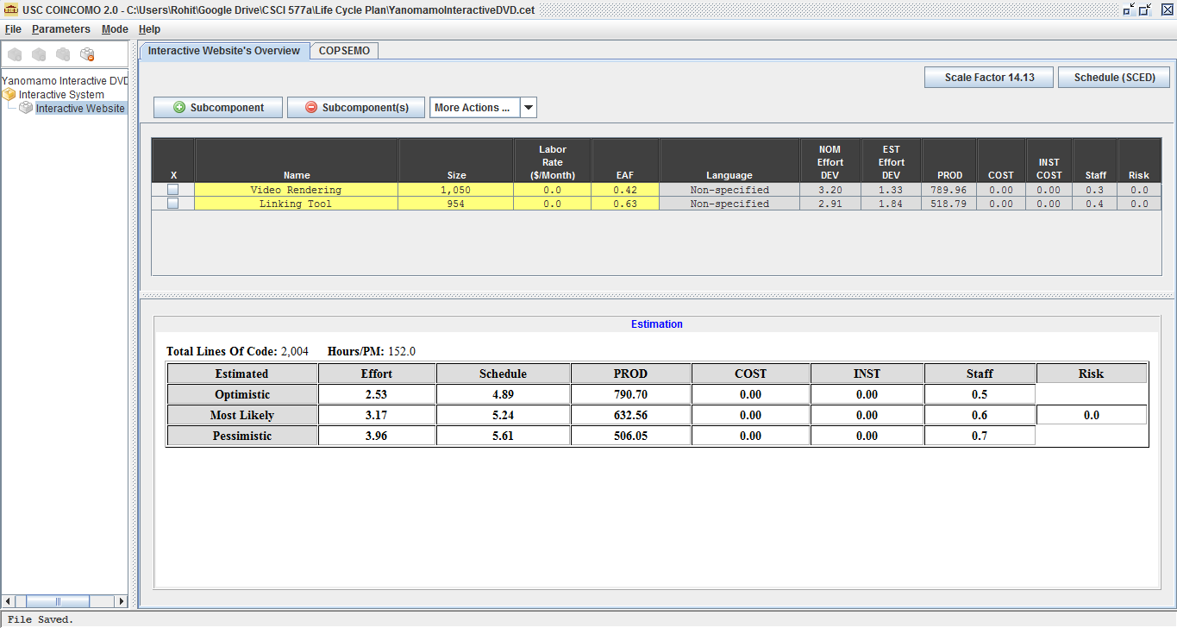
Figure 1: COCOMOII Estimation Results
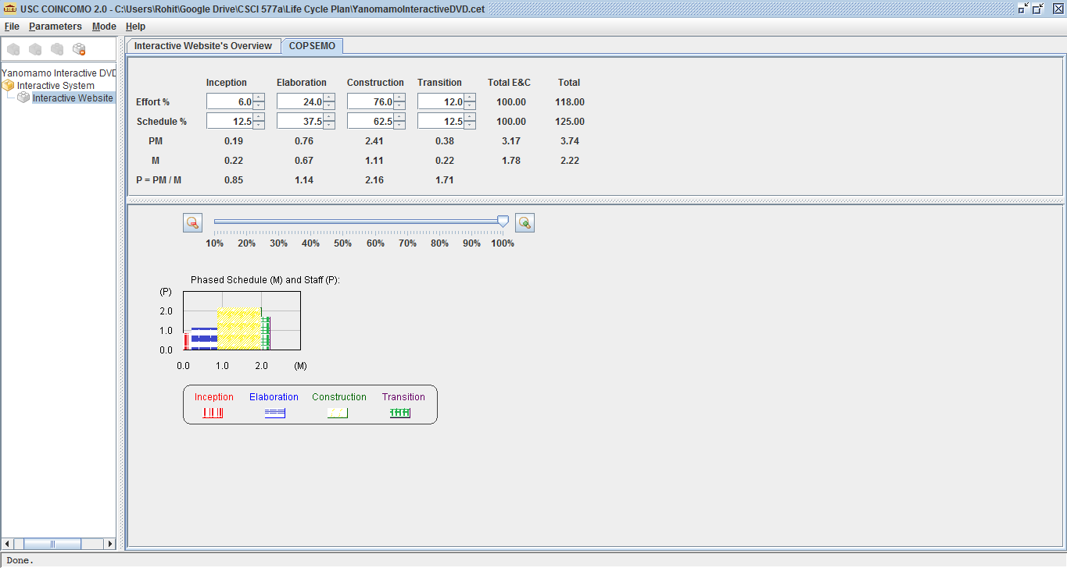
Figure 2: COPSEMO Tab
Table 10: COCOMOII Scale Drivers
Scale Driver | Value | Rationale
PREC | HI | The project is porting an existing system to a new platform
FLEX | NOM | Interface Flexibility. Rigid Requirements and Schedules
RESL | HI | All major risks are documented with mitigation plans for each
TEAM | VHI | No extra efforts needed to synchronize stakeholders
PMAT | NOM | ICSM Principles and Guidelines are followed strictly

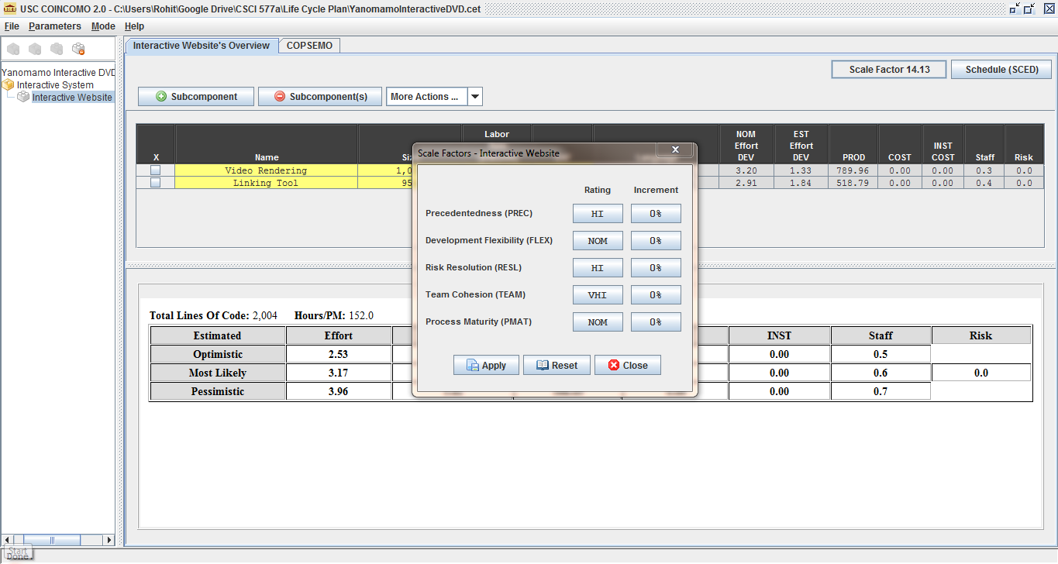
Figure 3: COCOMOII Scale Factors
Table 11: COCOMOII Cost Drivers for Video Rendering Module
Cost Driver | Value | Rationale
RELY | HI | If the system fails it will inconvenience the students. However, the system has a maintainer to reduce the possibility of failure
DATA | LO | There is no database required for the system
DOCU | NOM | Nominal Documentation is required for future maintenance
CPLX | VLO | No complex numerical analysis or calculations needed
RUSE | LO | This module is designed for a very specific purpose
TIME | NOM | The system consumes nominal time and resources
STOR | VHI | Video components might require more storage space
PVOL | LO | The platforms are stable and do not require frequent upgrades
ACAP | NOM | Analysts have basic experience
PCAP | HI | All the team members have experience with web development
PCON | HI | All team members will be available throughout the project
APEX | HI | All of the team members have moderate experience related to this module
LTEX | HI | High programming language and software tool experience
PLEX | NOM | Few team members have high platform experience
TOOL | LO | The tools used are moderately mature and very basic
SITE | VHI | All team members and clients are on campus

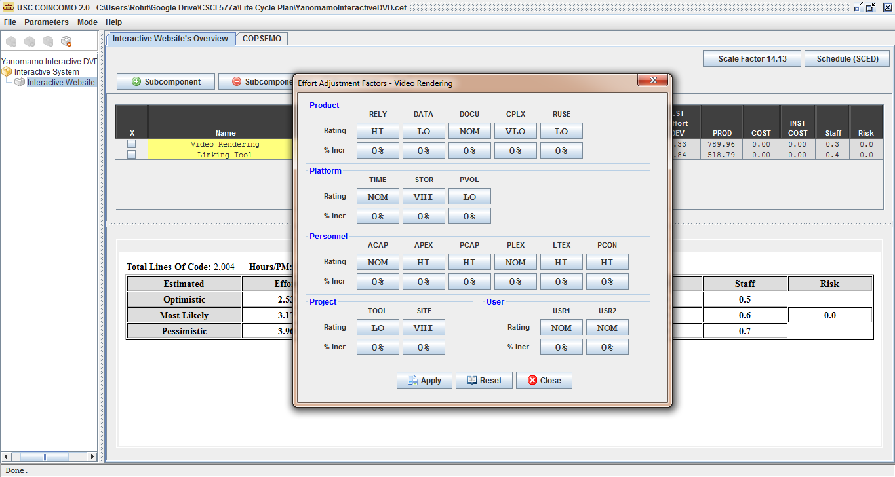
Figure 4: COCOMOII Cost Drivers #1
Table 12: COCOMOII Cost Drivers for Linking Tool
Cost Driver | Value | Rationale
RELY | NOM | If the system fails it will increase the time to link interactive elements. However, it is not an impediment in using the system
DATA | HI | There will be a test database required for the linking
DOCU | NOM | Nominal Documentation is required for future maintenance
CPLX | VLO | No complex numerical analysis or calculations needed
RUSE | HI | Can be a generic tool to link the video and interactive elements
TIME | NOM | The system consumes nominal time and resources
STOR | NOM | It does not require a lot of storage
PVOL | LO | The platforms are stable and do not require frequent upgrades
ACAP | NOM | Analysts have basic experience
PCAP | HI | Very few team members have extensive experience
PCON | HI | All team members will be available throughout the project
APEX | LO | All of the team members have low experience related to this module
LTEX | NOM | Moderate programming language and software tool experience
PLEX | NOM | Few team members have high platform experience
TOOL | LO | The tools used are moderately mature and very basic
SITE | VHI | All team members and clients are on campus

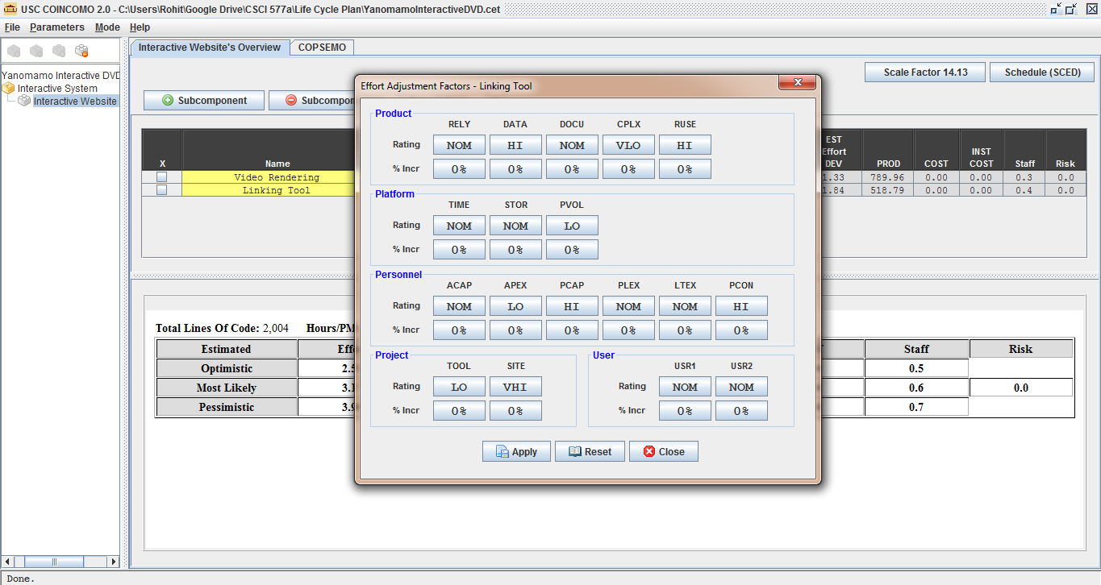
Figure 5: COCOMOII Cost Drivers #2

Results:
Pessimistic Estimated Effort: 3.96
Pessimistic Estimated Staff: 0.7

Schedule as an independent variable is used in the system (SAIV).

According to estimates for CSCI577a, one team member effort = 0.7 COCOMO II person months. The pessimistic effort from the COCOMO estimation above is 3.96, so the total team members need for this project = 3.96/0.83 = 5.66

As we have 6 members in our development team, the project will be able to finish on time.

6. Iteration Plan

6.1 Plan
The following iteration is planned for the Core Capability Drivethrough. During the Development Phase, the project team will start adding more functionality to the base system, namely the tab based navigation between features and dropdown list to select the type of text accompanying the video. In addition, as the functionality is provided, the development team will also start testing according to the TPC document. The team is also working on a linking tool to help the client map the Time Based Media to the interactive features.

6.1.1 Capabilities to be implemented
The bold capabilities will be implemented to deliver the core capability of the product. The normal text capabilities are already implemented while the light colored capabilities will be implemented in the last iteration.
Table 13: Construction iteration capabilities to be implemented
ID | Capability | Description | Priority | Iteration
1 | Play Time Based Media | The ability of the system to play Time Based Media | 1 | 1
2 | Link Text to TBM | The user should be able to click on a text and the video should skip to the relevant part | 1 | 1
3 | Link Stills to TBM | The user should be able to click on a text and the video should skip to the relevant part | 2 | 2
4 | Link Statistics to TBM | The user should be able to click on a text and the video should skip to the relevant part | 2 | 3
5 | Link Genealogies to TBM | The user should be able to click on a text and the video should skip to the relevant part | 2 | 2
6 | Provide written text for reading | The user should be able to click on a text and the video should skip to the relevant part | 3 | 3

6.1.2 Capabilities to be tested
The following are the win conditions that were agreed upon that have to be tested in this iteration.
WC_2326 - As a student, I can skip to any part of the video by clicking on the text
WC_2327 - As a student, I can play/pause/resume of videos to improve the learning environment
WC_2328 - As a student, I can resize the video to full screen

WC_2332 - As a student, I can view vital statistics of people in the video by clicking his/her name on the text and then display an identifying marker on the video
WC_2334 - As a student, I can view transcripts of the TBM
WC_2335 - As a student, I can view alternative interpretations by anthropologists (Chagnon) of the TBM/texts/literature/research papers

WC_2323 - As a professor, I can index stills to improve students' recognition of individuals and cultural facts
WC_2331 - As a student, I can view just the image gallery of stills.
WC_2338 - As a student, I can access static maps of the village in the video so that I know where people are in relation to others and geographically in relation to the rest of the world
WC_2324 - As a professor, I can index genealogies to improve students' recognition of kinship ties.
Table 14: Construction iteration capabilities to be tested
ID | Capability | Description | Priority | Iteration
1 | Play Time Based Media | The ability of the system to play Time Based Media | 1 | 1
2 | Link Text to TBM | The user should be able to click on a text and the video should skip to the relevant part | 1 | 1
3 | Link Stills to TBM | The user should be able to click on a text and the video should skip to the relevant part | 2 | 2
4 | Link Statistics to TBM | The user should be able to click on a text and the video should skip to the relevant part | 2 | 3
5 | Link Genealogies to TBM | The user should be able to click on a text and the video should skip to the relevant part | 2 | 2
6 | Provide written text for reading | The user should be able to click on a text and the video should skip to the relevant part | 3 | 3

6.1.4 CCD Preparation Plans
For the Core Capability Drive-through, the following stakeholders will be involved:
- Client: Dr. Gary Seaman
- Development Team Members (Team 06)

CCD Preparation Plan:

- The client will be informed of the latest features added to the system and why they were added in the order they were. This will establish the focus on the most important aspects of the system.
- The client will then be given a static/online copy of the system to test the video and the above mentioned linkage capabilities of the system.
- The testing team will have test cases ready for the client to run and will carefully document the results of each case.
- The client will be asked to run each test case and provide feedback on the usability and user interface.
- The client will be asked his opinion on changes to be made to the system and the development team will negotiate on these changes and identify feasibility during the session itself.
- The risks and test cases will be revised by the development team after revising the client feedback.

6.2 Iteration Assessment

6.2.1 Capabilities Implemented, Tested, and Results
Table 15: Capabilities implemented, tested, and results
ID | Capability | Test Case | Test Results | If fail, why?
1 | Play Time Based Media | TC-01-01,TC-01-02, TC-01-03 | Pass | -
2 | Link Text to TBM | TC-02-01, TC-02-05 | Fail | Rolling text not implemented.
3 | Link Stills to TBM | TC-02-03 | Pass | -
4 | Link Statistics to TBM | TC-02-03 | Pass | -
5 | Link Genealogies to TBM | TC-02-02 | Pass | -
6 | Provide written text for reading | TC-02-01 | Pass | -

6.2.2 Core Capabilities Drive-Through Results
- Positive Feedbacks: The most important capabilities (ID: 1,2,3,5) were all tested and working as expected. The client responded in a positive way to all the changes made after the last client meeting.
- Improvements needed: An improvement in text scrolling and video skipping capability was suggested by the client.
- Changes: The priority of deploying the system on an Apple Server has lesser priority than deploying the system on a DVD, Images should be linked in the transcript, Image gallery with photographs not just mug shots, on homepage show other images as well.
- Risks: No new risks introduced or mitigated.
- Notes: Client needs the system faster to perform all the linking, Expecting to use with students next semester

6.3 Adherence to Plan
- The iterations are going according to plan.
- The capabilities with the highest magnitude and probabilities of risk were implemented in the Prototype Review and CCD. Only the capabilities which have the least risk have to be implemented.
- All the team members are performing their duties efficiently without delay.
- The client and the development team are working together to get the linking done before the system has to be delivered.
- The test cases for all capabilities are documented and run as soon as a new capability is delivered.

